42.40: a) 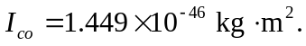

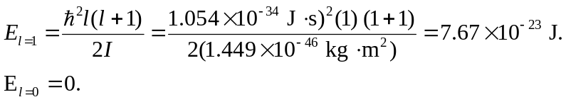
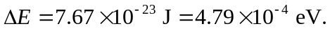
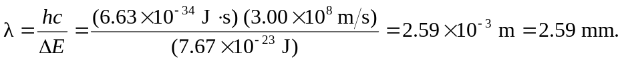
b) Let’s compare the value of kT when T=20 K to that of 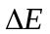 for the 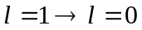 rotational transition:

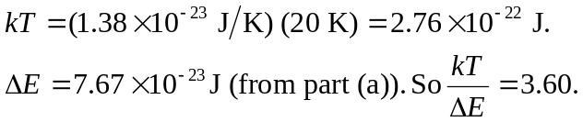

Therefore, although T is quite small, there is still plenty of energy to excite CO molecules into the first rotational level. This allows astronomers to detect the 2.59 mm wavelength radiation from such molecular clouds.

